Joshua Cutler

counting app user guide

Last edited 04 December 2018

Contents

[Getting Started 2](#_Toc531678521)

[Tools and Counts 3](#_Toc531678522)

[Select Tool 3](#_Toc531678523)

[Move Tool 3](#_Toc531678524)

[Draw Tool 4](#_Toc531678525)

[Zoom Tool 4](#_Toc531678526)

[Counts 4](#_Toc531678527)

[Text Inputs 5](#_Toc531678528)

[Adjust Image Display 5](#_Toc531678529)

[Brightness and Contrast 5](#_Toc531678530)

[Hide the Image Tool Bar 5](#_Toc531678531)

[Save Images and Counts 6](#_Toc531678532)

[Standard Save 6](#_Toc531678533)

[Save As 7](#_Toc531678534)

[Overlay Image with Counts 7](#_Toc531678535)

[Save Cropped Image 7](#_Toc531678536)

[Export Data to File 7](#_Toc531678537)

[Export Data to Database 7](#_Toc531678538)

[Work with Multiple Images 8](#_Toc531678539)

[The Configuration File 8](#_Toc531678540)

[Counts 9](#_Toc531678541)

[Inputs 9](#_Toc531678542)

[File to Export 9](#_Toc531678543)

[Database or Data Source Connection 10](#_Toc531678544)

[Database or Data Source Tables and References 10](#_Toc531678545)

[System and Image Metadata 11](#_Toc531678546)

# Getting Started

The Counting App is a single *exe* file that can be run on your Windows computers. It will not run on platforms other than Windows. Copy and paste the Counting App *exe* file into a folder on your computer. It is also highly recommended that you include a Configuration File (see [The Configuration File](#_The_Configuration_File)), which must be in the same folder as the *exe* file.

Double-click the *exe* to open the Counting App control window, which you can see in the top left corner of your screen and does not show in the Windows Taskbar at the bottom of your screen. To open an image, click C:\Applications\CountingApp3\CountingApp3\Resources\FolderOpen_16x.png *Open* in the menu or drag and drop the file into the control window. You can have any number of images open at the same time.

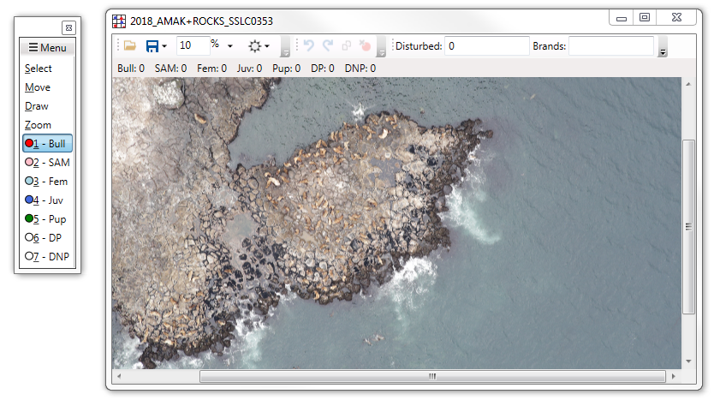

1.The Counting App first opens as a control window (left). Look for it in the top left corner of your screen. You can then open any number of image windows (right). Use the control window to select a tool or count, and to find menu options that apply to the whole app or all open images. Use the image window to add counts and find tools that apply to that image only.

At the top of the control window is the *Menu* with tools that apply to the whole app or all open images. Below the menu are 4 standard tools: *Select*, *Move*, *Draw*, and *Zoom*. These are followed by the count tools, each preceeded by a circle the color of the dots it creates. The counts are defined in the configuration file (see [The Configuration File](#_The_Configuration_File)); if none are defined there is a single default count tool. The single selected tool changes how your mouse behaves over image windows (see [Tools and Counts](#_Tools_and_Counts)).

For each image window, the file name is displayed at the top of the window. If you try to open the same image again, it will not open. The tool bar at the top of an image window affect that image only. The text inputs you may see in the tool bar are defined in the configuration file (see [The Configuration File](#_The_Configuration_File)); if none are defined there is a single default text input. The bar below the image tools display the summed category counts for that image only.

# Tools and Counts

The selected tool or count defines how your mouse behaves over the images. Click on any tool or count category from the list in the control window or press the keyboard key for the underlined character in its name to select it. For example, you can press the S key to use the *Select* tool. Only the first 10 count categories are assigned a number key, and all other counts can only be clicked to select. You can only select a single tool or count at a time.

## Select Tool

Click *Select* from the control window or press the S key. Click on a count dot or a drawn line to highlight it. You can also click and drag to highlight all count dots inside the box you just created. You can also hold down the CTRL key and click on a count dot or drawn line to add it to or remove it from the selected item collection. Click the C:\Applications\CountingApp3\CountingApp3\Resources\DeleteBreakpoint_16x.png tool at the top of the image window or press the DELETE key to delete the selected items. You can also click the C:\Applications\CountingApp3\CountingApp3\Resources\CopyToClipboard_16x.png tool or press the CTRL + C keys to save the cropped image inside the selection box as a new file.

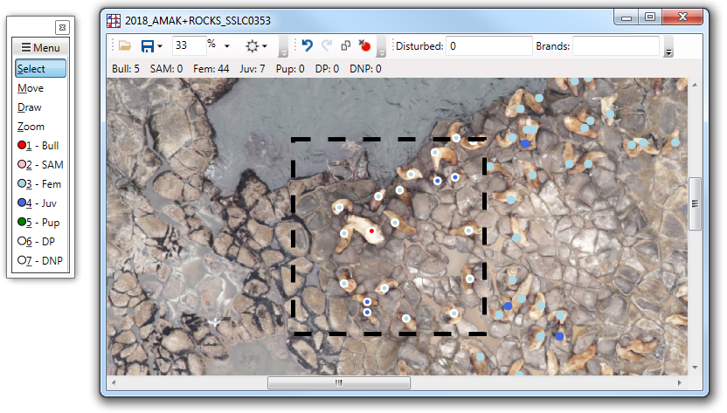

2.Click and drag the Select tool to highlight counts inside that box. You can also click on a count or line to select it. At the top of the image window you can then see the activated delete tool, which deletes the selected items, and the activated copy tool, which saves the cropped image inside the rectangle as a new file.

## Move Tool

Click *Move* from the control window or press the M key. You will most often use this tool to quickly scroll across the image; just click and drag across the image. You can also click and drag a selected item to move all of the selected items. Hold down the SHIFT key to quickly use the *Move* tool while any other tool or count is selected.

## Draw Tool

Click *Draw* from the control window or press the D key. Click and drag on the image to draw a line. Lines are stored in a separate file and are not permanently embedded in the image file; this means you cannot see the lines when you open the image in another app but you can move and delete them at any time in the Counting App.

## Zoom Tool

Click *Zoom* from the control window or press the Z key. Left-click on the image to zoom in on that point. Click and drag to zoom into the box you just created. Hold the CTRL key and left-click, or right-click on the image to zoom out. You can also use your mouse wheel to zoom in and out while any tool or count is selected. When using the mouse in any way to zoom, the image cannot be smaller than its window.

You can manually set the zoom percentage for an image from the tool bar at the top of its window. This text input is followed by % and an options drop-down list. Click the C:\Applications\CountingApp3\CountingApp3\Resources\FitSelection_16x.png *Fit to window* option to scale the image to fit completely inside its current window size. Click the *C:\Applications\CountingApp3\CountingApp3\Resources\ImageStack_16x.png* *Scale all images* option to scale all open images to match that image scale.

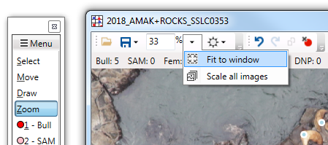

3.In addition to clicking on the image with the Zoom tool, you can manually adjust the zoom percentage of an image from the tool bar at the top of its window. This text input is followed by % and then an options drop-down list, which includes the Fit to window and Scale all images tools.

## Counts

The count categories are defined in the configuration file (see [The Configuration File](#_The_Configuration_File)). If no categories are defined, there is a single default count category. Click on a count category in the control window to use it. The first 10 counts can also be selected with the number keys (1 through 9, and 0 for the tenth category).

Click on the image while a count is selected to add a dot of its color. The total number of dots in an image for each category are displayed at the top of the window. The count dots are stored in a separate file and are not permanently embedded in the image file; this means you cannot see the dots when you open the image in another app but you can add, move, and delete them at any time from the Counting App. Be careful of overlapping dots that may look like one dot.

Right-click a count category in the control window and click *Hide* to hide the counts of that category in all image windows. Click it again to un-hide them. You cannot add counts of hidden categories.

You can adjust the size of the count dots displayed in the image windows. Click the *-* or *+* button next to C:\Applications\CountingApp3\CountingApp3\Resources\BreakpointXHR_16x.png *Dot Size* in the control window menu to make them smaller or larger, respectively. This is useful for reviewing your counts and adjusting the dot size when saving an image file embedded with the count dots (see [Save Overlay](#_Create_a_New)).

# Text Inputs

The text inputs in the tool bar at the top of the image windows are defined in the configuration file (see [The Configuration File](#_The_Configuration_File)); if none are defined there is a single default text input. If the window is too small to display all of the text inputs, it hides them in the tool bar overflow, which you can access by clicking on the far right arrow in the image tool bar. Text inputs are saved to a separate file with the counts and can be included in your outputs.

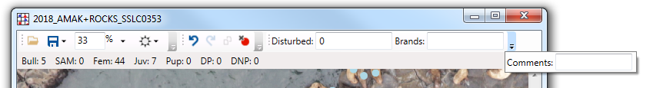

4.The text inputs are in the tool bar at the top of the image windows. If the window is too small to display all of them, it hides them in the tool bar overflow, which you can access by clicking on the far right arrow.

# Adjust Image Display

## Brightness and Contrast

Click on the C:\Applications\CountingApp3\CountingApp3\Resources\Brightness_16x.png tool at the top of the image window to access the controls. Use the control slide bars to adjust the brightness C:\Applications\CountingApp3\CountingApp3\Resources\Brightness_16x.png and contrast C:\Applications\CountingApp3\CountingApp3\Resources\Contrast_16x.png for that image only. Click the reset C:\Applications\CountingApp3\CountingApp3\Resources\RestoreImage_16x.png button to switch between the original and the last adjusted brightness and contrast values. When you save an image, cropped image, or overlaid image, the app ignores your adjustments and saves with the original brightness and contrast.

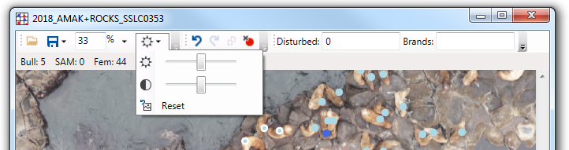

## Hide the Image Tool Bar

Click on *Show Image Menus* in the control window menu to hide the tool bar in all image windows. This gives you more space within the window to view the image and is useful in overlapping adjacent images. To access the image tools, you have to either click *Show Image Menus* again or use their keyboard shortcuts.

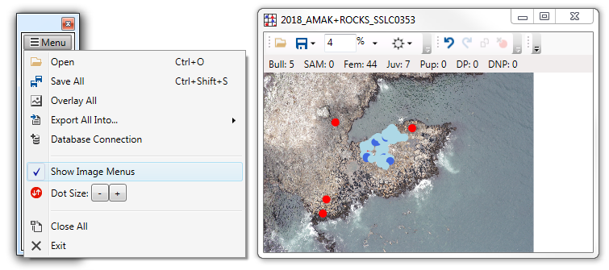

5. The Show Image Menus menu option in the control window (left) starts as checked so you can see the tools, text inputs, and count totals in the image windows (right).

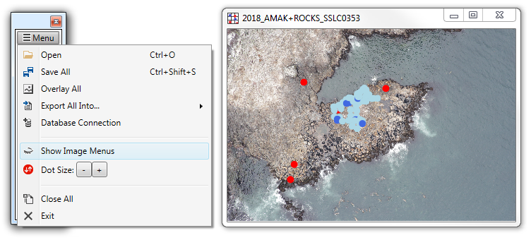

6. Click on the Show Image Menus menu option in the control window (left) to hide the tools, text inputs, and count totals in the image windows (right).

# Save Images and Counts

There are several options available for saving and exporting the data you collected from images. Take care in choosing which saving method you should use.

## Save

The standard method saves the data for a single image as a separate data file in the same folder and with the same file name. Next time you open that image file, the Counting App automatically reads the data file, allowing you to make changes to the counts, drawn lines, and text inputs from previous counting sessions. As you close an image window, you will be prompted to save your changes. We highly recommend that you choose “Yes”. You can save at any time by clicking the C:\Applications\CountingApp3\CountingApp3\Resources\Save_16x.png *Save* tool at the top of the image window or by pressing the CTRL + S keys. Do not make changes directly to the data file outside of the Counting App.

Click on *C:\Applications\CountingApp3\CountingApp3\Resources\SaveAll_16x.png* *Save All* in the control window menu or press the CTRL + SHIFT + S keys to save all of the open images using the standard method.

## Save As

You can save the image data file with a different name or to another folder. Click on the C:\Applications\CountingApp3\CountingApp3\Resources\Save_16x.png save tool at the top of the image window and then click C:\Applications\CountingApp3\CountingApp3\Resources\SaveAs_16x.png *Save As* to choose a new file name and folder. The image file will not move to that folder but the data file saves your image file location. When you open that data file with the Counting App, it will automatically locate its associated image file. However, if you open the image file in the Counting App, it will not know where that data file is.

## Overlay Image with Counts

When you save the images using the *Save* or *Save As* options, the count dots and drawn lines are not embedded into the image, and cannot be seen outside of the Counting App. Click on the C:\Applications\CountingApp3\CountingApp3\Resources\Save_16x.png save tool at the top of the image window and then click C:\Applications\CountingApp3\CountingApp3\Resources\ImageChisel_16x.png *Overlay* to save a copy of the image permanently overlaid with the count dots and drawn lines as a new image file. The overlaid objects are the same size as they appear in the image window when you zoom to 100%. Click on the C:\Applications\CountingApp3\CountingApp3\Resources\BreakpointXHR_16x.png *Dot Size* - and + buttons in the control window menu to adjust the object sizes before you save. Any adjustments to the brightness and contrast are ignored. You cannot move or delete the counts and lines from the overlaid image, and the Counting App cannot tally these counts.

Click on C:\Applications\CountingApp3\CountingApp3\Resources\ImageChisel_16x.png *Overlay All* in the control window menu to create an overlaid copy of each open image. It will rename them so that no file is over-written.

## Save Cropped Image

Use the *Select* tool to click and drag a box over the part of the image to crop. Click the C:\Applications\CountingApp3\CountingApp3\Resources\CopyToClipboard_16x.png tool at the top of the image window or press the CTRL + C keys to copy and save the selection as a new image file. Count dots and drawn lines are not included in the cropped image, and adjustments to the brightness and contrast are ignored.

## Export Data to File

You can export the data of all open images as a new file. The data fields are defined in your configuration file (see [The Configuration File](#_The_Configuration_File)) and can include count category totals, image window text inputs, image metadata, and system attributes. Each image file will have its own row or entity in the exported data file. Click on C:\Applications\CountingApp3\CountingApp3\Resources\ResultToText_16x.png *Export All Into…* in the control window menu and then C:\Applications\CountingApp3\CountingApp3\Resources\ResultToText_16x.png *File* to begin exporting. You will then be prompted to enter a file name and choose a file type (tab-separated, comma-separated, or xml). Take care to choose the appropriate file type for your next steps in data processing. If you need to append new data to an existing file, you may be able to use the export to database tool (see [Export Data to Database](#_Export_Data_to)) instead, depending on the file type.

## Export Data to Database

You can export the data of all open images into a database or another data source [supported by Microsoft OLE DB](https://docs.microsoft.com/en-us/sql/analysis-services/tabular-models/data-sources-supported-ssas-tabular?view=sql-server-2017) like Access, SQL Server, Oracle, and Excel. This tool appends the data from each image as its own row to an existing data source, unlike the export to file tool (see Export Data to File) which creates a new file. Click C:\Applications\CountingApp3\CountingApp3\Resources\ResultToText_16x.png *Export All Into…* in the control window menu and then C:\Applications\CountingApp3\CountingApp3\Resources\WriteToDatabase_16x.png *Database* to begin exporting.

The image data fields have to be mapped to the database columns in the configuration file (see [The Configuration File](#_The_Configuration_File)). You can define the connection string and enter a password in a secure way using the C:\Applications\CountingApp3\CountingApp3\Resources\AddDataSource_16x.png *Database Connection* tool in the control window menu, and the Counting App retains that connection for as long it is running. You can also click *Save* in the *Database Connection* tool to save your connection without a password to the configuration file. If you manually change the connection string in your configuration file, do not include your password. Instead, enter your password into the *Database Connection* tool every time you run the Counting App.

# Work with Multiple Images

You can have many images open at the same time in the Counting App. Click on C:\Applications\CountingApp3\CountingApp3\Resources\FolderOpen_16x.png *Open* in the control window menu, click on C:\Applications\CountingApp3\CountingApp3\Resources\FolderOpen_16x.png in any image window tool bar, press the CTRL + O keys, or drag and drop files into any window to open any number of image files. No matter how you open them, each image that is not already open in the Counting App opens in a new window. To keep the App running smoothly, image windows that you are not actively using have a low resolution; you may notice this when you zoom in on an image and then click on another image window.

Click on the zoom tool drop-down at the top of an image window and click C:\Applications\CountingApp3\CountingApp3\Resources\ImageStack_16x.png *Scale all images* to match the zoom scales for all images to that image window. New image windows will open at that scale too.

Use the menu tools in the control window to save all images, save an overlaid copy of all images, and to export all image data to a file or database. When you export to a file or database, the data of a single image is its own single row.

# The Configuration File

The configuration file (*config.txt*) tells the Counting App what count categories to use, what counts and other data to export, and how to export it. The configuration file has to be saved to the same folder as the other Counting App files. If you make changes to the file while the Counting App is running, you have to completely exit the app and then run it again to see those changes. Use the guidelines here to create or modify your configuration file using any text editor (e.g. Notepad). The Counting App includes a tool to help you create a database connection string in the configuration file, but all other elements have to be done by you.

Without a configuration file, the Counting App has one count category, one text field for *Notes*, and exports the following fields to file: file name, current date, date the file was last modified, your Windows login user name, and the *Notes* text field. Even if you build a database connection string in the Counting App, you cannot save to a database without manually entering the database table names, column names, and values into the configuration file.

The Counting App reads the configuration file line-by-line. Start a line with 2 dashes (--) to have the App ignore reading it, which is useful for writing comments and temporarily ignoring lines. A read line must start with the element name, which are described below, followed by a colon and the value. An element part cannot span multiple lines. The App ignores spaces and tabs, so feel free to use them to make it easier to reading.

Table 1. How to define each element type in the configuration file (config.exe). For elements that require multiple lines, make sure you have every required line immediately after each other. Do not separate them with blank lines.

|  |  |  |
| --- | --- | --- |
| Element Type | Text Format | Example |
| Comment | --[Comment] | --Remember to change Initials |
| Count Category | Count: [Name], [Color] | Count: Bull, Red |
| Input | [Name]: [Value] | Initials: JC |
| File Column-Values | File Columns: [Column 1], [Column 2], ...  Values: [Value 1], [Value 2], … | File Columns: Counter, Bull  Values: JC, Bull |
| Database Connection | Database Connection: [Connection String without a password] | Database Connection: Data Source = LocalDBServer; Initial Catalog = SSL; Integrated Security = SSPI |
| Database Table | Database Table: [Table Name]  Columns: [Column 1], [Column 2], …  Values: [Value 1], [Value 2], … | Database Table: aerial.Count  Columns: Counter, Bull  Values: JC, Bull |
| Database Referenced Table | Reference Table: [Table Name]  Columns: [Column 1], [Column 2], …  Values: [Value 1], [Value 2], …  Return: [Column 1], [Column 2], … | Reference Table: aerial.SurveySite  Columns: SiteName  Values: Marmot  Return: SiteID |

## Counts

Include a *Count Category* line for each count type to add to the control window tools. Start the line with “Count:” followed by a unique name, a comma, and then the color of those count dots. Use a short name that is easy to read and identify in the control window (e.g. use “DP” instead of “Dead Pups”). This name is for display in the Counting App, and does not have to be the category name saved to file or a database. Use a color name recognized by [CSS standards](https://developer.mozilla.org/en-US/docs/Web/CSS/color_value) (e.g. Red) or an RGB hex value (e.g. #FF0000). If the color name is missing or cannot be recognized, a unique random color is assigned every time the App runs. The count categories in the control window list will be in the same order as in the configuration file.

## Inputs

Include an *Input* line for a value that can be entered and edited for each image. Start the line with the input name followed by a colon. You can then follow the colon with an optional default value. Use a short name that is easy to read in the limited tool bar space at the top of the image windows (e.g. use “Site” instead of “Site or Beach Name”). This name is for display and does not have to be the column name exported to file or a database.

## File to Export

The *File Column-Values* element defines the data included in the file created when you export data to file (see [Export Data to File](#_Export_Data_to_1)). Start the first line with “File Columns:” followed by a comma-separated list of columns as they will appear in the exported file. Start the next line with “Values:” followed by a comma-separated list of value references in the same order as the columns. If a reference matches a count or input name exactly (it is case-sensitive), the Counting App fills that value with the count total or text input. You can also reference system and metadata values (see [System and Image Metadata](#_System_and_Image)). Instead of referencing an image-specific value, you can include a literal that will export exactly as you write it here for every image. Wrap literal values with single quotes and escape single quotes inside the value with 2 single quotes (e.g. ‘this columns’’s value’). Values that do not match any count, variable, system, or metadata name are treated as literals.

## Database or Data Source Connection

Include a single *Database Connection* line to save to a database or another data source (e.g. Excel file). Because the configuration file is not secure, DO NOT save your username and password to the file. Start the line with “Database Connection:” followed by a recognized [OLEDB connection string](https://www.connectionstrings.com). You may also elect not to include this line, and instead create a connection in the Counting App every time you run it. Click on the C:\Applications\CountingApp3\CountingApp3\Resources\AddDataSource_16x.png *Database Connection* menu item in the control window, fill out its options, and then click *Apply*. This overrides the connection string read from the configuration file and the Counting App remembers this connection for as long as it is running. To save or over-write the connection string to the configuration file, click *Save*. Your user name and password are not saved, should never be manually entered into the configuration file, and must be completed in the *Database Connection* tool every time you run the Counting App.

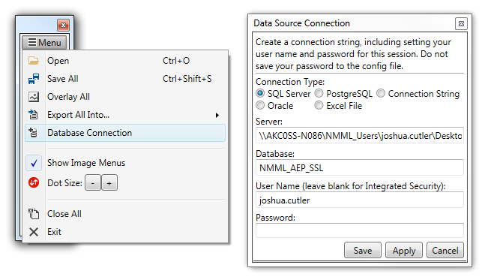

7. Change the database or data source connection with the Database Connection menu tool in the control window (left). Choose the Connection Type and then fill out the information that type requires (right). If the connection requires a username and password, enter then into this tool every time you run the Counting App.

## Database or Data Source Tables and References

If you are going to export data to a database (see Export Data to Database), you have to specify the table name, table columns, and value with a *Database Table* element. Start the 1st line with “Database Table:” followed by the table name. Start the 2nd line with “Columns:” followed by a comma-separated list of the relevant database table column names. Start the 3rd line with “Values:” followed by a comma-separated list of value references in the same order as the columns. If a reference matches a count or input name exactly (it is case-sensitive), the Counting App fills that value with the count total or text input. You can also reference system and metadata values (see [System and Image Metadata](#_System_and_Image)). Instead of referencing an image-specific value, you can include a literal that will export exactly as you write it here for every image. Wrap literal values with single quotes and escape single quotes inside the value with 2 single quotes (e.g. ‘this columns’’s value’).

Values that do not match any count, input, system, or metadata name are assumed to be a database routine. Wrap all references to a count, input, system, or metadata name in double-quotes. For example, if all image files are names as *SiteName.jpg*, you can export the site name into the database using the value *SUBSTRING(“FileName”, 1, CHARINDEX(‘.’, “FileName”) - 1)*. The commas inside the routine do not break the comma-separated values list.

To help you find all of the values you need to enter into your *Database Table*, you can use image values to find values from other database tables. You can use any number of these *Reference Table* elements. Start the first line of each of these elements with “Reference Table:” followed by the table name. Start the 2nd line with “Columns:” followed by a comma-separated list of the column names from that table to use for matching. Start the 3rd line with “Values:” followed by a comma-separated list of the value references in the same order as the columns. Start the 4th line with “Return:” followed by a comma-separated list of the reference table columns to use as new value names. You can then reference the returned column names as if they were count, input, system, or metadata names in the *Values* line of your *Database Table* element. If the returned column names conflict with another name, you can call it *column name AS new name* and reference it exactly the same. When you export data to the database, the Counting App looks for rows in the database *Reference Tables* where all of the column values match those defined here, and returns the values from the first of those rows. If the Counting App cannot find a matching row, it saves a new row in the *Reference Table* with those column values, and returns the values from the new row.

If a column name contains a special character (e.g. a space), you should surround it with square brackets. If a table or column name contains a period (.), surround it with square brackets ([ ]). Do not surround the item with square brackets if the period is there to specify the schema containing the table or the table containing the column. When using an Excel file as a data source, all table names must end with a dollar sign ($).

## System and Image Metadata

The following names are automatically recognized in the file, database, and referenced table *Values* lines and do not need to be declared as an input. If you declare an input or count with the same name, that value will override the system or metadata value.

System attributes: *FileName*, *Computer*, *Directory*, *DateModified*, *UserName*, *CurrentDate*, and *DateCreated*.

Image metadata tags: *Artist*, *BodySerialNumber*, *CaptionWriter*, *Copyright*, *Creator*, *DateCreated*, *DateTime*, *DateTimeDigitized*, *DateTimeOriginal*, *Description*, *Headline*, *ImageDescription*, *Keywords*, *LensModel*, *LensSerialNumber*, *Make*, *Model*, *Rights*, *Subject*, *TextEntry*, *Title*, and *UserComment*.